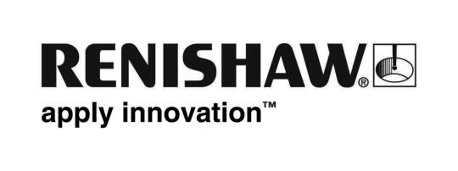
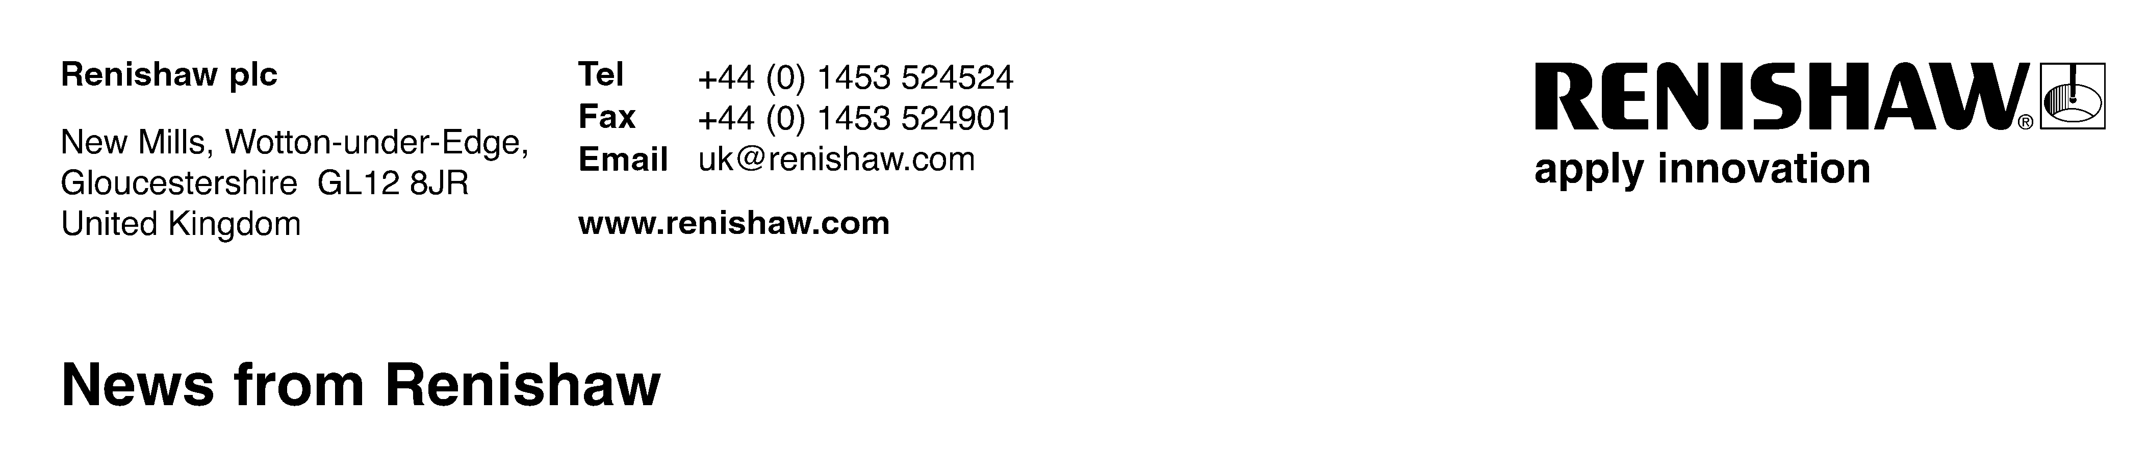
6th November 2013
Enquiries: Chris Pockett, Head of Communications (+44 7887 833391) chris.pockett@renishaw.com

Renishaw is awarded new international standard for waste reduction
Renishaw, the UK-based global engineering company, is amongst the first five businesses to achieve the new Carbon Trust Waste Standard which was launched on 5th November 2013. The world’s first international standard for organisational waste reduction, it is awarded to businesses able to demonstrate that they are measuring, managing and reducing waste year on year. Following the successful completion of a pilot stage, Renishaw has achieved the award together with Whitbread, PwC, AkzoNobel Decorative Paints UK, and the Football Association.

Calling on businesses to take urgent action to become more sustainable, Tom Delay, Chief Executive of the Carbon Trust, said:

“We are living beyond our means, drawing on natural resources at a rate that cannot continue without leading to an ecological and economic crunch. Organisations that fail to bring sustainability inside their operations will face the consequences of increasingly scarce or expensive commodities, water and energy.

“Reducing waste and resource use, along with carbon emissions and water, is a crucial part of the transformation that all businesses will need to make in the next decade. By taking early action and opening themselves up to independent certification showing real reductions, the businesses that hold our Standards are showing themselves to be genuine leaders and are putting themselves in a much stronger competitive position.”

To achieve the Carbon Trust Waste Standard, Renishaw has demonstrated an overall movement up the waste hierarchy, increasing rates of reuse and recycling. The company was also certified earlier this year to the Carbon Trust Standard for carbon emissions.

Ben Taylor, Renishaw’s Assistant Chief Executive, said, “As an advanced manufacturing business, increasing efficiency and reducing waste in our operations and processes is fundamental to what we do. We are delighted to be recognised by the Carbon Trust for our ongoing work to improve how we deal with our waste, through prevention, reuse and recycling wherever possible.”

Renishaw has also turned waste into a valuable resource. The company invested £196,000 to install systems that turn waste aluminium swarf from production processes into briquettes that can be sold on to other manufacturers, creating a new revenue stream. It is also assessing the viability of further equipment that will enable the company to recover waste oils from metal cutting operations.

Going through the Carbon Trust Waste Standard assessment process has catalysed improvements in the business’ waste management systems that should help it continue making reductions in future years.

Renishaw is also at the forefront of research into systems that will in the future help to limit industrial waste. It is the UK’s only manufacturer of a metal-based additive manufacturing (‘3D printing’) machine which allows items to be produced by building them up using the exact amount of resources required, rather than having to create components out of larger pieces of material using subtractive manufacturing processes.
Ends

Waste facts (source: Carbon Trust)
- Around the world it is estimated that around 11.2 billion tonnes of solid waste are collected each year.
- The decomposition of organic waste is responsible for around 5% of global greenhouse gas emissions.
- In the UK alone the waste sector is responsible for 17 million tonnes of carbon emissions a year, around 3% of all UK emissions.
- WRAP estimate that by 2020 moving towards a circular economy has the potential to increase the UK’s net exports by more than £20 billion and create 10,000 new jobs in just the recycling sector.
- The resource management sector in the UK already generates more than £13 billion a year in sales and employs more than 40,000 people.
- In 2014 UK landfill tax will be £80 a tonne.
- UK government figures outline that British businesses have a £50 billion opportunity for making savings through resource efficiency in waste. Of these savings, £18 billion is identified as being achievable through low or no cost measures, with a payback of less than one year.
- The average European generates around half a tonne of waste a year. More than a third of this goes to landfill and only a quarter is recycled.

About the Carbon Trust Waste Standard:
The Carbon Trust Waste Standard certifies organisations that measure, manage and reduce their solid and hazardous waste. To achieve the standard organisations will need to demonstrate that waste streams are being reduced every year, or used of more effectively, for example through increased reuse, recycling or energy recovery.

More information at www.carbontrust.com/wastestandard

About Renishaw
Renishaw is a world leading engineering company (LSE:RSW), primarily supplying measurement products used for applications as diverse as jet engine and solar panel manufacture, through to dentistry and brain surgery. It is also a leader in the field of additive manufacturing, with machines that enable manufacturers to ‘print’ metal parts. The company has 2,200 staff at its 15 UK locations, designing & manufacturing the majority of its products, plus a further 1,100 people located in the 32 countries where it has wholly owned subsidiary operations.

Over 94% of Renishaw’s sales are due to exports, with China, USA, Germany and Japan its largest markets. Celebrating its 40th anniversary in 2013, its success has been recognised with numerous international awards, including sixteen Queen’s Awards rewarding achievements in
technology, export and innovation. Further information at www.renishaw.com

